Supplementary Information
Submitted to: FRONTIERS IN MICROBIOLOGY

Shear Stress Affects Biofilm Structure and Consequently Current Generation of Bioanode in Microbial Electrochemical Systems (MESs)
Jiawei Yang, Shaoan Cheng*, Chaochao Li, Yi Sun and Haobin Huang
State Key Laboratory of Clean Energy, Department of Energy Engineering, Zhejiang University, Hangzhou 310027, PR China
* Correspondence:
Dr. Shaoan Cheng
E-mail: shaoancheng@zju.edu.cn;

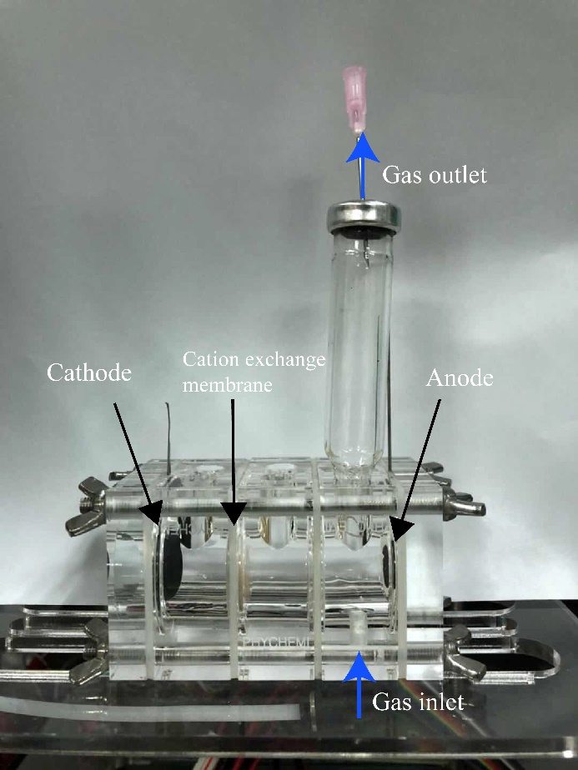
FIGURE S1 Photograph of the MFC.
FIGURE S2 Nyquist plots of the EIS spectra of the MFCs. The inset shows the equivalent circuit that was used to estimate the anode resistance.

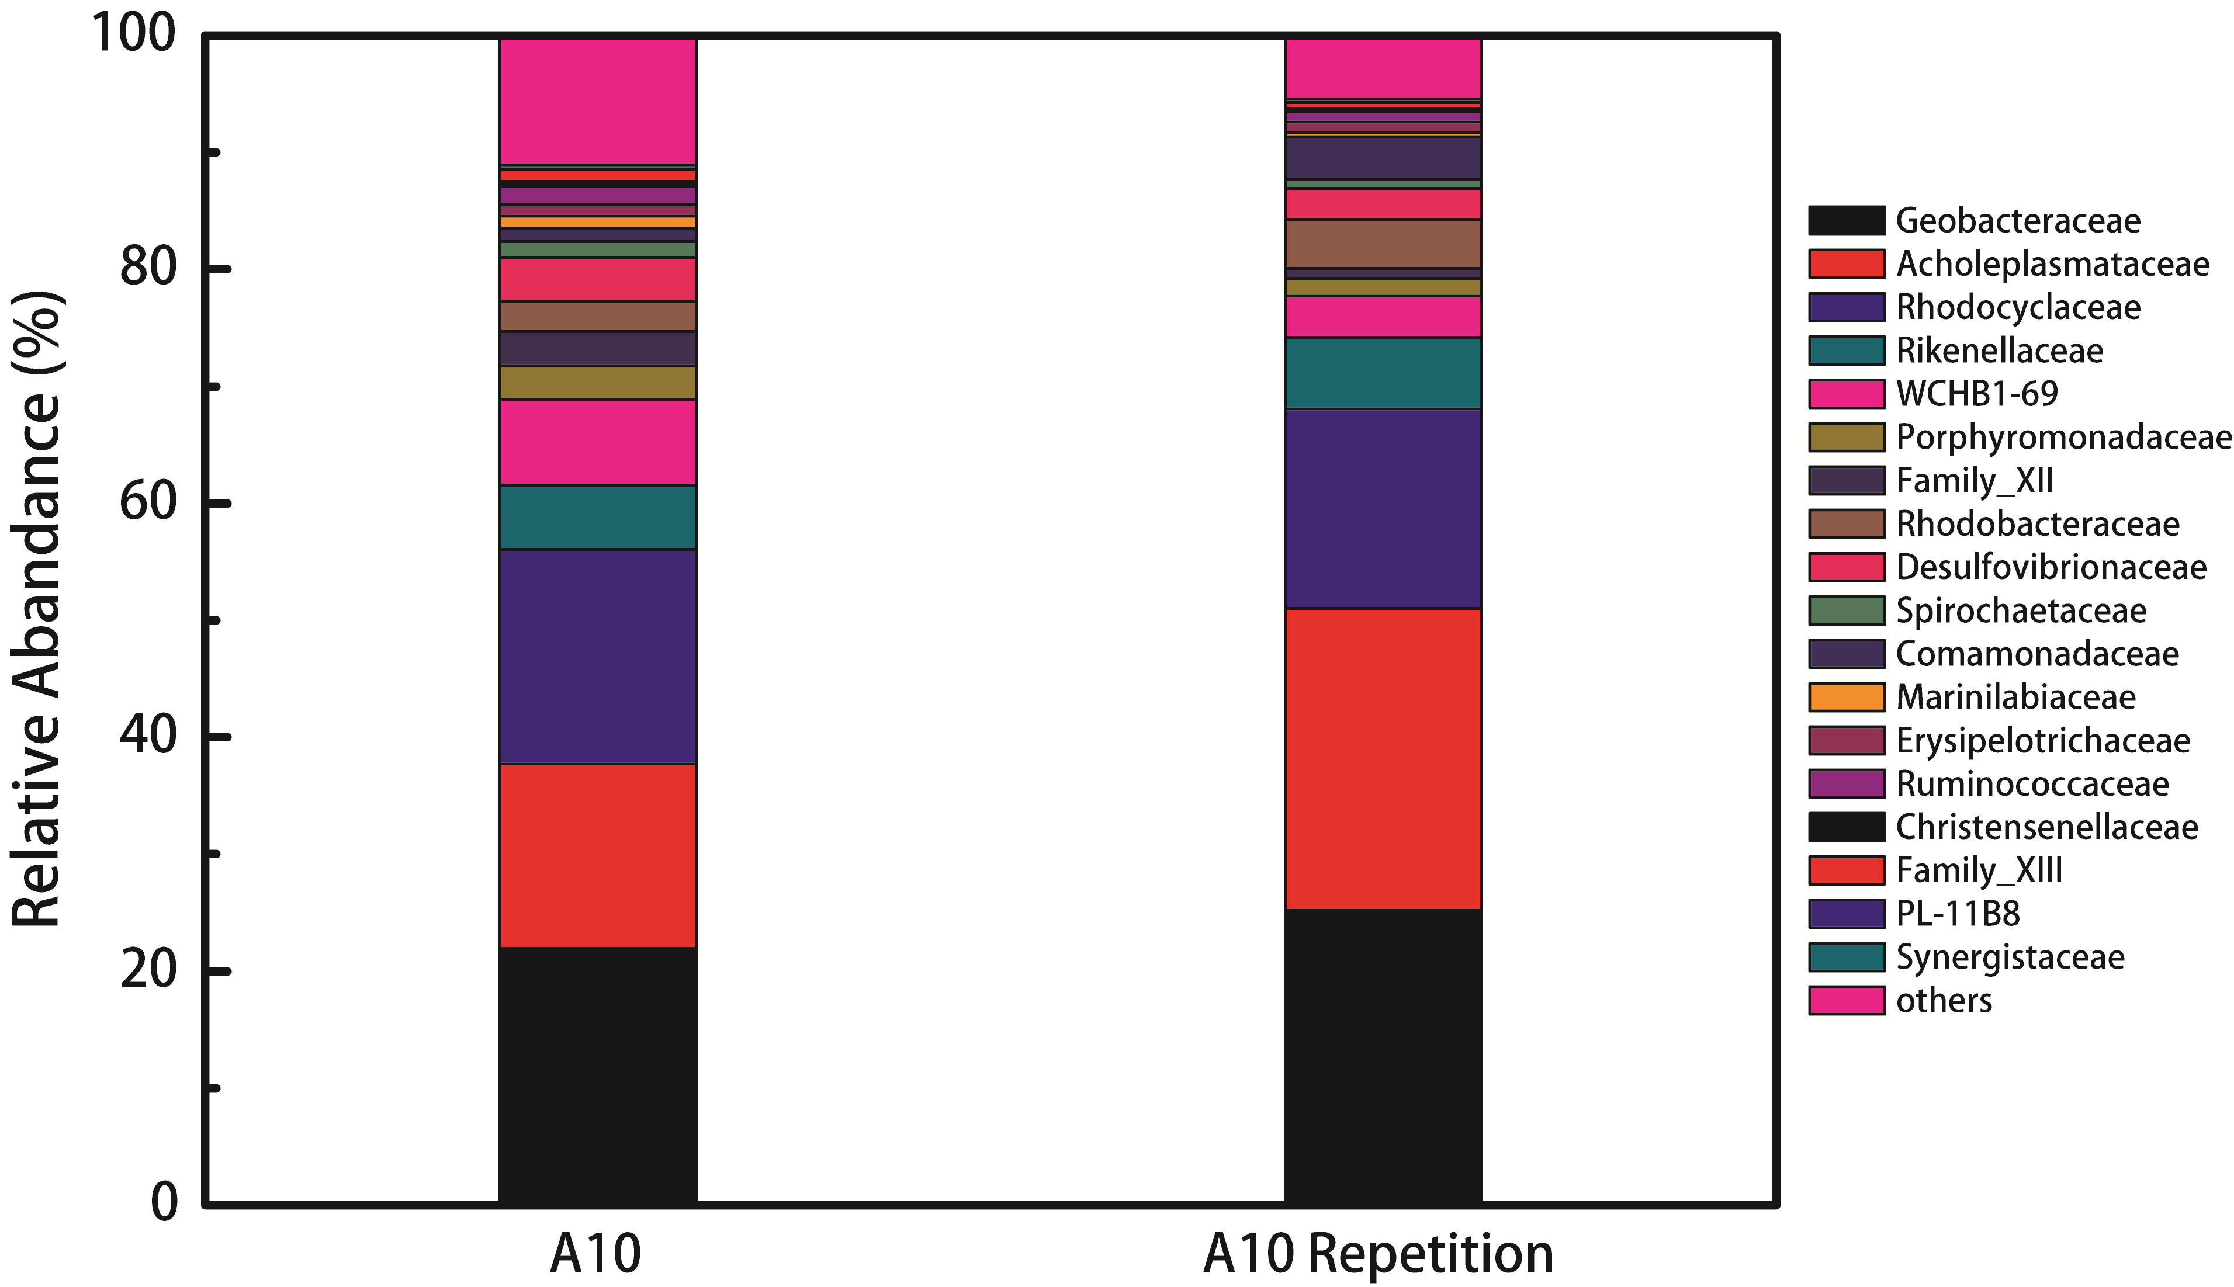

FIGURE S3 Composition and relative abundance of bacteria in A10 at the family level.

